Task No. 03: Write a Program to print your Profile using C#.

Solution:

using System;

namespace Profile

{

class Program

{

static void Main(string[] args)

{

Console.WriteLine("My Profile");

Console.WriteLine(" -My name is Abdullah Sadiq.\n -My Father name is Muhammad Sadiq.\n -I am 17 year old.\n -I have done Fsc from Bahria College(NORE-1).\n -I am a student of Software Engineering at Bahria University(Karachi Campus).\n -My Hobby is Photography. I do it because I like it. ");

}

}

}

Output:

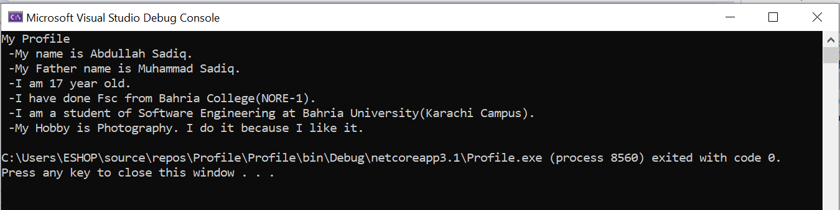

5